Phase 1: The Repository Setup
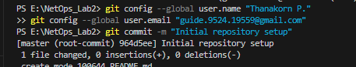
Phase 2: The Physical Build
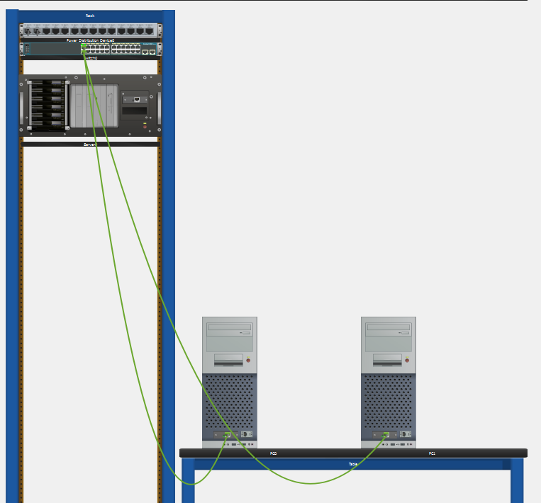

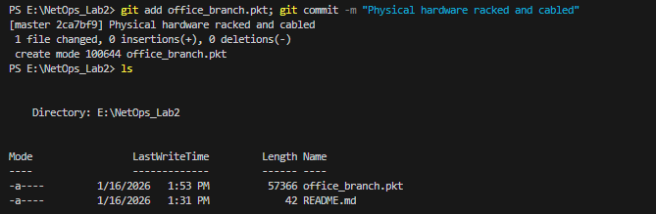
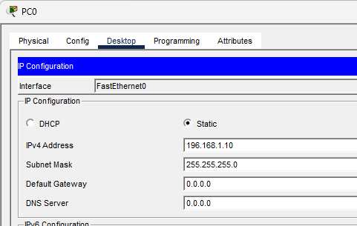

Phase 3: The Logical Config 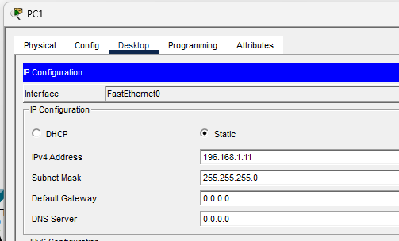
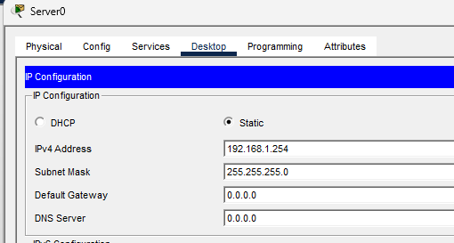
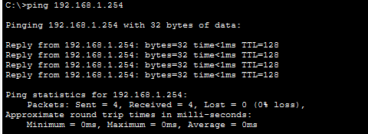
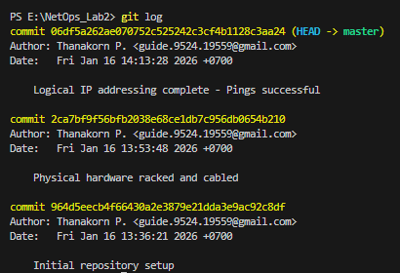
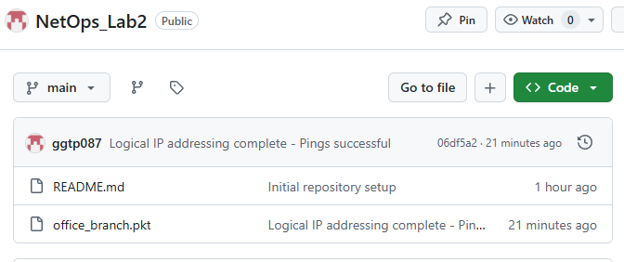
Phase 4: The Challenge Question
In Packet Tracer's Physical view, if the distance exceeds 100m, what happens to the cable color? How does this impact your "Physical vs. Logical" documentation?
Ans. In physical view, it limits the cable length to not exceed 100 meters. So, the cable color will turn to red which means the connection is down. So, the physical will cause the problem because of real-world physical limitation. However, the logical view is still worked and connected.

